Updated 11/25/19

HLA Diagram

Web Server/Host

User Database

Facebook API

Payment Processor

HLA Diagram v2:

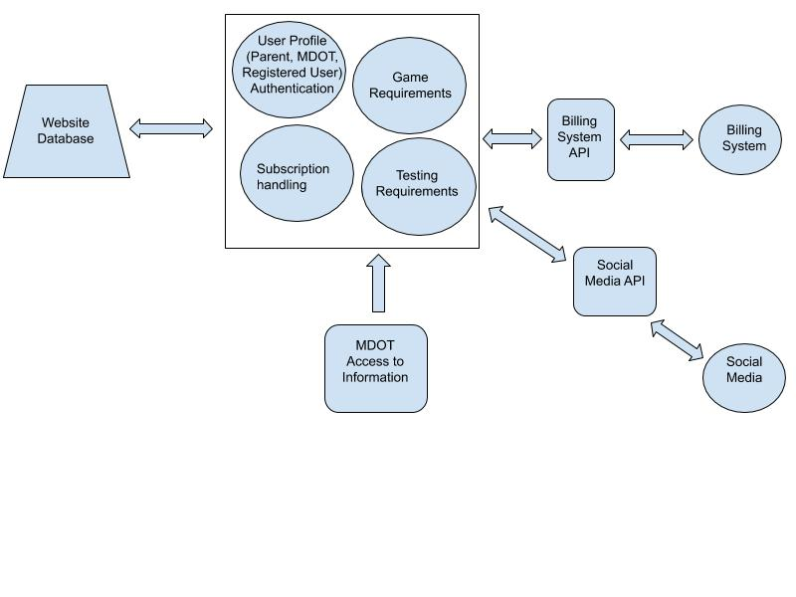

|  |
| --- |
| Limit Login Attempts Reloaded |
| Controls the amount of times that someone can attempt to login to their account. |

Class Diagram

|  |
| --- |
| WP File Manager |
| The file manager works with allowing us to upload the game to the website. |

|  |
| --- |
| Ultimate Member |
| This allows members to register and who has confirmed their emails. |

|  |
| --- |
| Social Media and Share Icons |
| Includes the widgets for what types of social media that they can share. |

|  |
| --- |
| Profile Builder |
| This is used for recovering passwords, login form/registration form. |

|  |
| --- |
| Paid Membership Pro |
| This deals with paid subscriptions. |

|  |
| --- |
| Elementor |
| Creates an easy way to template out a page with images, shortcode, etc |

|  |
| --- |
| Contact Form 7 |
| Contains name, email, subject, and message where they can send to an email for information or help needed. |

Interface Specification:

|  |  |  |
| --- | --- | --- |
| <<Facebook Interface >> | <<Game Interface >> | <<Database Interface>> |
| * Share scores | * Questions * Answers | Keeps track of :   * Scores * Questions * Answers |

|  |
| --- |
| <<Admin Interface>> |
| * Can add more questions * Keep track of users |

|  |
| --- |
| <<PaymentProcessor Interface>> |
| * PayPal collects monthly fee if they are a subscriber |